Kootenay Planning Consultants
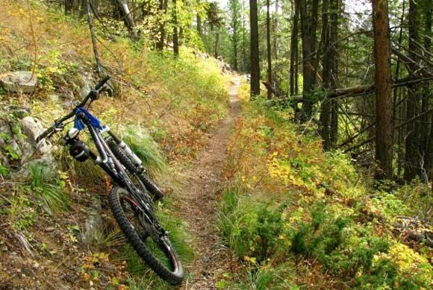
Barbour Rock Recreation Trails Plan
Columbia Valley Greenways Trails Alliance and Columbia Valley Cycling Society
2/27/2017

(Updated from July 9, 2016 Version)
Kootenay Planning Consultants
P.O. Box 2548
Invermere, BC V0A 1K0
250-688-1353
Columbia Valley Greenways Trail Alliance
P.O. Box 2377
Invermere, B.C., V0A 1K0
Columbia Valley Cycling Society
P.O. Box 1033
Invermere, B.C., V0A 1K0

Barbour Rock Recreation Trails Plan
Columbia Valley Greenways Trails Alliance and Columbia Valley Cycling Society

Executive Summary
The Columbia Valley Greenways Trail Alliance (CVGTA) and the Columbia Valley Cycling Society (CVCS) are proposing to develop a sanctioned epic trail system totaling approximately 30 to 40 km. The trails are proposed to be located completely on Crown land in the well-known Barbour Rock area of the Columbia Valley approximately 7 km from the District of Invermere on the north side of Toby Creek Road (see Appendix ‘A’: Location Map). The trail system is made up of three distinct components: the multi-use/mixed ability Green trail; the signature cross-country mountain biking Barbour Rock trail; and, the hiking-only trails to the ridge summits.
The Green trail is proposed as a wide, family friendly, multi-use trail. This figure eight trail loop stays close to the Toby Creek Road and provides access to all of the other trail loops. One side of the figure eight heads west towards the base of Barbour Rock providing access to the hiking only trails, cross-country mountain trails and the climbing crags; while the other side of the figure eight loop heads east towards Bear Mountain Forest Service Road (FSR) and some cross-country mountain trails.
The signature cross-country mountain trails Barbour Rock trail, shown as red on the Proposed Barbour Rock Recreation trail map (Appendix B), is made up of two distinct loops separated by Bear Mountain FSR. This trail is designed as single track mountain bike trail with varying levels of difficulty from the less experienced intermediate to very experienced intermediate. The majority of the cross-country mountain trails are designed as ‘Blue’ level trails to serve the average ability level of rider. There are some expert sections on the trail but all include easier ride-arounds to by-pass these challenging areas.
The hiking-only trails are shown as brown on the proposed trail map (Appendix ‘B’) extending from the west limit of the Green multi-use trail. These trails are designed and will be built specifically with the hiker in mind, offering opportunities to reach the summit of Barbour Rock ridge passing the climbing crags on the way.
The proposed Barbour Rock Recreation trail system will add to the existing inventory of authorized recreational trails in the Columbia Valley. The Barbour Rock Recreation trails will reduce the number of users on the existing Lake Lillian Trail system, thereby reducing trail impact and increasing trail user enjoyment on these Lake Lillian Recreation trails are all trail users.
The Barbour Rock Recreation trail system will be designed and constructed as ‘sustainable trails’ under the Recreation Sites and Although these trail standards are required to be implemented by RSTBC, CVGTA and CVCS recognize the importance of building trails to these standards as this will ensure the trails are safe; sensitive areas are protected; damage to the surrounding natural environment will be reduced; and all the necessary components to make the trail a fun and exciting mountain bike ride can be included.
The Barbour Rock Recreation trail system as proposed is one component in achieving the goals and objectives of the CVGTA Trails Vision – 2017. Several elements of the CVGTA Trails Vision – 2017 can be found in Barbour Rock Recreation trail system plan such as but not limited to the following:
- Sanctioning trails to ensure good design, management and maintenance
- Provide recreation trail for a variety of ability levels and user groups
- Design the trail system in loops for added enjoyment
- Include signage which is consistent throughout the Columbia Valley
The CVGTA and CVCS have undertaken extensive time and effort to address the concerns and issues brought forward during the initial conversations with adjacent landowners and affected stakeholders, the feedback from the RDEK Areas F and G APC members, Ministry of Environment and all comments received at the two Public Open House information events.

“We love the idea of a recreation area, close to town and close to a paved road. This is a huge benefit as the trails would be available earlier in the season than the trails in the alpine. Great for users who only want to spend a couple of hours”.
The Summit Trail Makers Society (STMS)

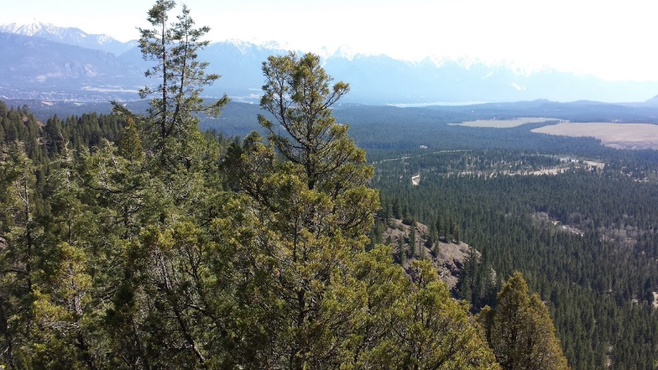
View from Barbour Rock Summit overlooking Columbia Valley

Table of Contents
Executive Summary 3
1. Background 8
History of Barbour Rock and Surrounding Area 8
Historic Land Uses in the Barbour Rock Area 8
2. Barbour Rock Recreation Trail Partners 11
Columbia Valley Greenways Trail Alliance 11
Columbia Valley Cycling Society 11
Summit Trail Makers Society 11
Recreation Sites and Trails BC 12
3. Trail Planning Overview 13
Trends 13
Recreational Trail Benefits 13
4. Trail Considerations 16
Terrain of Area 16
Trail User Groups 17
Adjacent Landowners/Stakeholders 18
General Public Input and Consultation 19
5. Trail Design 22
Trail Standards 22
Trail Alignment 24
User Considerations 25
Parking / Trailheads 26
Signage 26
5. Trail Construction 28
6. Maintenance 30
7. Proposed Budget 31
8. Future Intentions for Trails in the Area 32
9. Conclusion 33
References 34
APPENDIX ‘A’: Barbour Rock Recreation Trail System Location Map 35
APPENDIX ‘B’: Barbour Rock Recreation Trail System Proposed Trail Map (January 2017 Version) 36
APPENDIX ‘C’: Barbour Rock Recreation Trail System Stakeholder Comments 39
APPENDIX ‘D’: Letters of Support 42
APPENDIX ‘E’: VAST Resource Solutions 46
APPENDIX ‘F’: Eva M. Boehringer, MRM, RPBio 48
APPENDIX ‘G’: Open House Sign-In Sheets and Comments – January 20 & 21, 2017 50
APPENDIX ‘H’: Preliminary Field Reconnaissance Report (PFR) - Tipi Mountain Eco-Cultural Services Ltd. 51

Columbia Valley Cycling Society (CVCS) - Dedicated to growing the sport of cycling for the health and wealth of our community through a sustainable trail network and respect of public and private land.
The Columbia Valley Greenways Trail Alliance (CVGTA) - envisions the region between Canal Flats and Donald, BC as connected by land and water greenways.

1. Background
Trails for recreational use can be found all over the Columbia Valley, the Province of BC and across the country. Recreational trails are very popular as they offer fitness and outdoor recreation opportunities to people of all ages, abilities and socio-economic status. There are fewer sanctioned recreation trails; that is those that have been reviewed and approved by a Government Approving Agency; than non-sanctioned or rogue trails. The sanctioned recreation trails in the Columbia Valley are primarily managed by recreational trail user groups or volunteer organizations who keep them clear and accessible. Sanctioned trails can be officially mapped and advertised thus becoming an excellent tourist attraction feature. Informal, unauthorized and rogue trails are not maintained to any standard, if at all and cannot be mapped or advertised or use controlled. Well-designed sanctioned recreation trails can provide many benefits to the communities surrounding the trails. Some of the more, well documented, benefits include: tourism opportunities; protection of the environment; and better control and management of the trail and trail users.
In BC in 2010, there were approximately 41,821 km of managed recreation trails throughout the province, of which approximately 2,260 km were specifically designed and approved for various types of mountain bike activities and 3,995 km for the shared use of walking/biking (Norman, 2010). These statistics demonstrate how popular recreation trails are across the Province. Locally the Columbia Valley has seen increased numbers of local and visiting mountain biker trail users. During the spring and summer months, cross-country mountain bikers of all ability levels, hikers and walkers can be found enjoying one of the Columbia Valley’s sanctioned Lake Lillian trail system. RSTBC collected trail counts on the Lake Lillian Trail System during from the summer of 2013 to end of season 2014. These counts show weekly trail users during this time period averaging 250 to 550 (Recreation Sites and Trails BC). The Kloosifier trail (a popular trail in the Lake Lillian Recreation Trail system) had a counter located on it and the totals showed significant increase of use over the time period of the survey. It is anticipated that winter trail traffic will also increase as fat tire bikes and cross country skiers hit the trail using the tracks set by the Toby Creek Nordic Club. As the Lake Lillian Recreation Trail system becomes more well-known use will increase and potentially come to a point that damage to the environment will occur because of too many users. The planning for the Barbour Rock Recreation Trail system is anticipation of this happening and hopes to be in place before any damage can occur. The Toby Benches Official Community Plan recognized the popularity of mountain bike activities in this area and the need to manage the impact of increased trail use.

History of Barbour Rock and Surrounding Area
Barbour Rock is named after the John Smith Barbour family who owned a ranch in the area in the early part of the 1900’s and stayed there until sometime in the 1950’s (Weller, 2013). The rocky outcrops of Barbour Rock have been accessed by climbers for many years as the crags are challenging, close to Invermere and offer early season snow free climbs.

Historic Land Uses in the Barbour Rock Area
The Crown land that the proposed trail system covers has seen extensive human use and impact over the years. The area has been logged several times, used as cattle range, harvested for Christmas trees, home to trap lines and hunting, used by recreationalists for ATVs, hiking, snowshoeing, cross-country mountain biking. The Toby Benches OCP acknowledges that the southern exposure and relatively low snow-pack on the Toby Benches makes trail use popular in the spring as this area is the first to be snow free and a “substantial number of trail users beginning to visit the area as early as March”. (RDEK Toby Benches OCP. p.16)
There are several Crown Tenures covering the Crown parcel and surrounding area, these Tenures include the following commercial uses/operators:
- Cattle Range;
- Trap line;
- Forest harvesting, including Christmas Tree harvesting (Perry Horning);
- Electric Power Lines (as mentioned previously); and
- Private use of Bear Mountain FSR (Seels and Barry Brown-John).
The proposed addition of recreation trails will not eliminate any of the existing tenure operations or activities. The proposed recreation trails aim to work in coordination with these existing approved uses.
The parcel of Crown land the proposed recreation trails would be located on is surrounded on three side by private land parcels; to the north, to the east and to the south. The Toby Creek Road runs along the south side and Bear Mountain FSR runs through the middles of the subject area. Two major BC Hydro power transmission line rights of ways also crisscross the crown land of this proposal. (See Appendix ‘A’ Location Map)

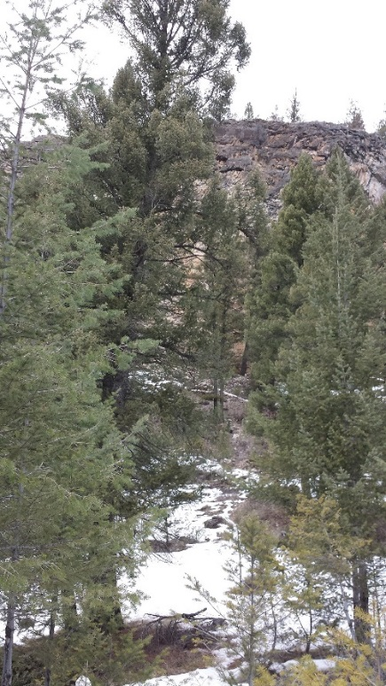
Barbour Rock Crag

2. Barbour Rock Recreation Trail Partners
The Barbour Rock Recreation Trail System is being proposed by a group of partners who all see the huge benefits of planning and development recreation trails in the Columbia Valley that are well managed and maintained for locals and visitors alike. The organizations included in this proposal to develop a Barbour Rock Trail System include: the Columbia Valley Greenways Alliance, the Columbia Valley Cycling Society, the Summit Trail Makers Society, and Recreation Sites and Trails BC.

Columbia Valley Greenways Trail Alliance
The Columbia Valley Greenways Trail Alliance (CVGTA) is a multi-stakeholder group of individuals and member organizations working together to create a world-class network of interconnected multi-use recreational trails and green spaces throughout the Columbia Valley from Canal Flats to Donald. Greenways Trail Alliance work is focused on collaborative efforts between various groups to achieve access to natural spaces for recreation, education and a thriving community. All CVGTA activities are done with the idea that respect for the environment increases when groups plan, build and maintain trail systems together. In the CVGTA Trails Vision 2017, the CVGTA stated that “the Columbia Valley is ripe for trail development”. (CVGTA Trails Vision 2017. P.5). The CVTGA Trails Vision 2017 supports the development of recreation trails in the Barbour Rock area, especially as a link between existing and future trails in the area between Invermere and Panorama. (CVGTA Trails Vision 2017. P.28)

Columbia Valley Cycling Society
The Columbia Valley Cycling Society (CVCS), is a volunteer organization based in the Columbia Valley and is made up of mountain bike enthusiasts. CVCS’s vision is to grow the sport of cycling for the health and wealth of the Columbia Valley communities through sustainable trail networks that have been built and maintained to respect the land and those around it. The Society’s primary mission is “to enjoy and promote mountain biking opportunities in the valley by developing and maintaining a network of legal, non-motorized trails”. Currently the CVCS is fulfilling its mandate by maintaining and managing 60 km of trails; including the Mt. Swansea Trail Network and the Lake Lillian Trail system; all RSTBC sanctioned mountain bike trails on Crown Land.
CVCS is a proud member of the Greenways Trail Alliance and strongly believes that the development and maintenance of new multi-use recreational trails, like the proposed Barbour Rock Trail System will help the Greenways Trail Alliance meet their goals and vision.

Summit Trail Makers Society
The Summit Trail Makers Society is made up of a group of hikers whose mission is to promote safe and sustainable hiking experiences by assisting in the development and maintenance of back country hiking trails in the Columbia Valley region. The Summit Trail Makers support the development of the Barbour Rock Recreation Trail System as they will provide hiking opportunities close to Invermere, that will have safe easily accessible parking and will at an ability level that the average hiker and achieve. During the development of the Barbour Rock Recreation Trail system the Summit Trail Makers has provided valuable input on the design, alignment and construction of the ‘hiking only’ trails. It is anticipated that the Summit Trail Makers will assume maintenance responsibility of the hiking only trails in the future.

Recreation Sites and Trails BC
Recreation Sites and Trails BC represents the provincial ministry responsible for recreation sites and trails in the Province of BC. Recreation trails throughout the province are considered and regulated through various legislation and policies. The Trails Strategy for British Columbia makes it very clear that trails, whether motorized or non-motorized are recognized for the benefits they provide and are a high priority in recreation development in the Province. The proposed trail development in the Barbour Rock area can assist in meeting the goals of RSTBC in the East Kootenay area.
Although this trail plan proposes that the CVGTA and CVCS will manage and maintain the trails, the lands are and will remain under the jurisdiction of the Provincial Government. The Trails Strategy document requires trail development to include several key components:
- Collaborative planning
- Good governance
- Sustainable resources
- Effective management
- Comprehensive information; and,
- Strategic marketing
Partnering with the CVGTA and the CVCS will ensure the components are included in the trail plan and all future construction and maintenance activities and will ensure a trail system that the Columbia Valley will be proud of.
Future trail partners of the Barbour Rock Recreation trail system could include the Toby Creek Nordic Society, if interest is expressed for cross country ski track setting on the Green Loop trail.
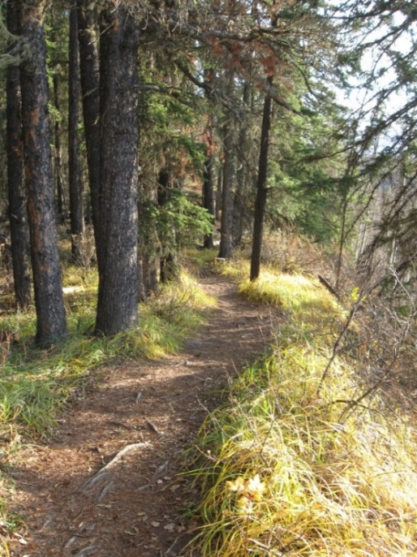
Example of Recreation Trail in BC
Figure 3: Example of an Existing Recreation Trail

3. Trail Planning Overview
The good trail planning, construction and maintenance of the proposed Barbour Rock Recreation Trail system will ensure the trails will become an asset not only to the trail users, CVGTA/CVCS and trail partners, but all of the Columbia Valley as well.
Currently there is only approximately 60 km of sanctioned trails in the Columbia Valley servicing locals and visitor of approximately 40,000 during the summer months. In the neighbouring community of Golden, there are upwards of 200 km of sanctioned trails for only ¼ of the summer population of the Columbia Valley. The addition of the Barbour Rock Recreation Trail system will ease the strain on the existing sanctioned trails in the area.

Trends
Recreational trends in BC and around the world show that people are moving away from organized sports and recreation towards more unstructured types activities such as; hiking, biking (both road and mountain biking) and cross-country skiing etc. which generally require some kind of recreational trail, such as the proposed Barbour Rock Recreation trail system. The BC Recreation & Parks Association (BCRPA) has determined that trends in recreational activities across the province indicate there will be a general increase in the usage of recreational trails and other natural outdoor spaces due to their low user cost and flexible use (BCRPA, 2006). The Barbour Rock Recreation trail system will expand the recreational trail opportunities for Columbia Valley locals and visitors alike.

Recreational Trail Benefits

Social Benefits
Numerous studies throughout Canada and the United States have been completed which state the benefits of recreational trails. One of the most significant benefit of the provision of recreation trails is that they provide easy access for a broad spectrum of people to get outdoors and be active at a very low cost, if any. Trail users themselves personally benefit when using the trails in terms of meeting their daily physical activity needs for a healthy lifestyle. The BC Select Standing Committee on Health has confirmed that the benefits from an active lifestyle, from using recreation trails for instance, include: living longer, staying in the workplace longer, and contributing to a generally healthier population (BCRPA, 2006). All positive benefits to any community close to a recreation trail. The Barbour Rock Trails system and all recreational trails in the Columbia Valley, provide opportunities for locals and visitors alike to pursue healthy living activities while enjoying the outdoors.

Economic Benefits
Local economies also benefit significantly from sanctioned recreational trail. Tourists are attracted to an area that has recreational trails that are officially mapped and advertised resulting in increased spending in the community. A recent study by Tourism BC and a number of partners, found that the majority of BC mountain bikers (both cross country and downhill riders) share a common profile: they are generally male, between the ages of 18 to 44, fully employed and approximately two-thirds of them have a post-secondary diploma or a University degree (Destination BC Corp., 2013). These trail users are known to spend their money: at local bike shops; at local food and beverage businesses; and at various types of accommodations providers. The study also found that the majority of visiting mountain bike trail users to BC were from the USA (Figure 1: BC Tourism Mountain Biking Statistics). Currently these surveyed visitors were primarily going to the few well-known BC mountain bike spots, such as: Whistler, Rossland and Golden. With the development of the Barbour Rock Recreation trail system, along with the existing Lake Lillian Recreation trail system, USA mountain bike visitors may look to the Columbia Valley for mountain bike adventure opportunities because of our close proximity to the border thereby bringing additional desirable economic benefits to the area. In 2011 Tourism BC has also conducted Mountain Bike Visitor surveys in communities similar in size to the Columbia Valley; Golden and Rossland. This survey was completed to determine if and what the economic impact of the intentional development of mountain bike trails was in these areas. The conclusion from these surveys was that the mountain bikers Golden, who were both locals and visitors, spent approximately $930,000 in the community in one season; while the mountain bikers surveyed in Rossland, also both locals and visitors, spent approximately $589,000 in one season. These expenditures by the mountain bikers varied from gasoline to accommodation, and from food and beverage, to general shopping (Destination BC Corp., 2013). Similar surveys in Whistler, Squamish, and even Williams Lake (Northern BC Bike Tourism) showed the same types of positive economic benefits to the local economies.
Figure 1: BC Tourism Mountain Biking Statistics
Statistics on Mountain Bike Travelers from the US to BC
- Approximately 305,000 mountain biking tourists travelled to British Columbia from the U.S. representing 6% of the pleasure travel population
- Mountain bikers are three time more likely to travel to British Columbia because of its reputation as a world class reputation for mountain biking
- BC has attracted 12.8% of the US mountain biking market
- Significant population of mountain bikers live in the Pacific states: Washington, Oregon, and California
Source: Mountain Bike Tourism Plan, BC Tourism. 2010

The addition of trail systems like the Barbour Rock Recreation trail could offer opportunities for similar economic benefits to the Columbia Valley.
“Mountain biking and mountain biking travel is growing and is a significant activity. Mountain biking tourism is a significant contributor to local economies, but tourists don't come to places unless there are unquantifiable things such as a strong local bike culture steeped in trail building and advocacy volunteerism and a healthy trail system.” (Lau, 2014)
A sanctioned trail network can be a key part of a broader tourist destination marketing strategy as it contributes to the image of a healthy, active and vibrant community. A high quality trail network can also attract high profile events such as mountain bike races or cross-country running events. The Barbour Rock and Lake Lillian Recreation trail systems have the potential to become a major tourist attraction to the Columbia Valley.

Environmental Sustainability Benefits of Good Trail Development
Parks Canada has concluded that all outdoor recreation, including nature-based tourism, has long been recognized as impacting the natural systems of an environment, with the potential to affect soil, vegetation, wildlife, or water quality. (Miistakis Institute, 2010) In short, if trails are designed and built as ‘Sustainable Trails’ as per the US National Park Service, Rocky Mountain Region (Richards, 1991), whether the trail use is by mountain bikes, horseback riding or hiking there is always an impact. See Figure 2 below for the definition of ‘Sustainable Trails’. The key to managing the impacts of human recreational activity is ultimately about understanding and managing for an acceptable level of change. The majority of environmental impacts occurs when the trails are initially put in after which the actual use of the trails has limited impact; “cross country mountain biking has similar impacts to the environment as other forms of summer season trail use” (Miistakis Institute, 2010). The CVGTA Trails Vision 2017 document also identifies research that supports the previous statement that non-motorized trail usage, on trails that are properly built and regularly maintained, can exist with minimal environmental impacts. Research and analysis of recreation trails around the province, the country and the world shows that the area adjacent to the trails can be protected with care and attention to choosing the location of the trail, establishing good trail alignment, constructing and continually maintaining the trail to a high standard as is expected by RSTBC. Using these important components the proposed Barbour Rock Recreation Trail system are being well planned so as to direct trail users away from sensitive area thereby protecting any fragile environments in the areas; paying close attention to the alignment, to avoid straight runs downhill for instance; and have a solid record of good maintenance procedures.
Figure 2: Definition of a Sustainable Trail
Sustainable Trails
Definition:
- Supports current and future use with minimal impact to the area’s natural systems.
- Produces negligible soil loss or movement while allowing vegetation to inhabit the area.
- Recognizes that pruning or removal of certain plants may be necessary for proper trail construction and maintenance.
- Does not adversely affect the area’s wildlife.
- Accommodates existing use while allowing only appropriate future use.
- Requires little rerouting and minimal trail maintenance.
-- From the National Park Service, Rocky Mountain Region, January 1991 (Richards, 2007)

4. Trail Considerations
A recreational trail proposal, such as this one, must consider several factors in the design and construction; some of which are the following:
- the area terrain, location of sensitive and significant features;
- who will user the trail – Trail User Groups; and
- what is the impact on adjacent land owners and stakeholders;

Terrain of Area
Barbour Rock is on the west side of the Columbia Valley located in the transition area between the valley bottom, the bench areas and the eastern slopes of the Purcell Mountains. As VAST Resources Solutions has indicated in their “Vegetation Assessment and Recommendations for Proposed Barbour Rock Trails” report, the Barbour Rock area is within the Interior Douglas-fir, dry mild, Kootenay variant (IDFdm2) Bioclimatic Ecosystem Classification (BEC) zone. The proposed trails cover ground that is: flat; has steep inclines; follows rock outcroppings and ridges; and, uses existing roads and trails or creates new ones.
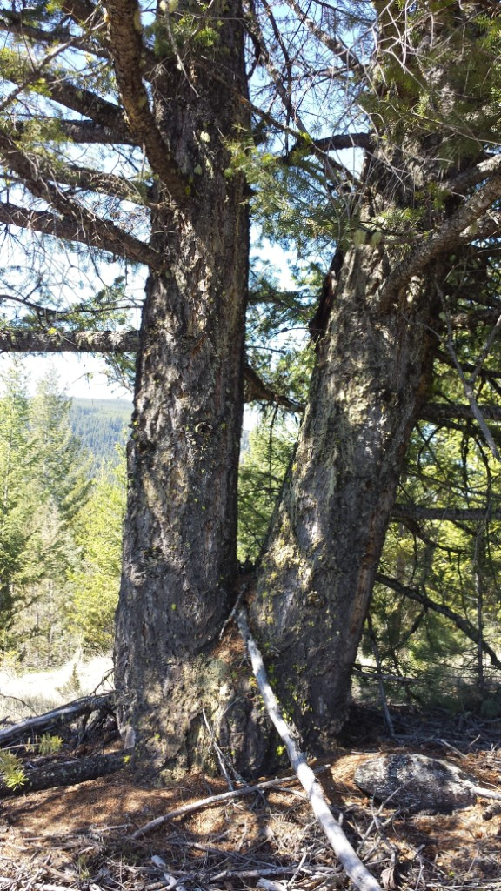
All recreational trails must be planned and designed to balance the desire to create a place for recreation and the need to protect the environment. A goal of recreational trail building is to ensure a long-term relationship between the human users and the surrounding natural environment by building a sustainable trail. A sustainable trail, as defined by the US National Park Service (shown in the Figure 6: Definition of a Sustainable Trail), is one that is not only easy to maintain but one that becomes a part of the landscape by minimizing the environmental impacts (Richards, 2007). Poorly built trails adversely impact the environment by deteriorating over time, cause drainage damaging and take away from the trail users’ enjoyment. The cost of poorly designed and built trails are extremely high and reducing their value to a volunteer based organizations such as CVGTA and CVCS. An objective of the Barbour Rock Recreation trail system is to work with the terrain and the existing features in order to reduce the need for significant alterations to the natural terrain and future expensive maintenance activities.
Douglas Fir, a Common Tree in the Barbour Rock Area
As protection of the environment is important to all of the partners involved in the Barbour Rock Trail System Plan a Registered Biologist was engaged to look at the area around the proposed trail, do an assessment of the potential impacts and come up with any mitigation measures or recommendations on how the trail construction could be done in a low impact manner. VAST Resource Solutions of Cranbrook undertook the project and provided a plant species and plant community assessment overview; identified possible areas of concern; and, came up with a number of recommendations for trail construction to reduce the actual and potential impact of the trail during construction. VAST also considered the impact of trail development on badger habitat and provided some recommendations to mitigate possible conflicts.
VASTs recommendations focused on the design and construction of the proposed Barbour Rock Recreation trail system as the point at which the most significant impact on the environment will occur which agrees with previous quoted research. VAST provided recommendations for actions and activities that will avoid disturbing to Red-listed plant species that could occur in the area, such as:
- having copy of the Red-listed plant list be on-site during all trail construction and take pictures for identification if any Red-listed plant are observed; and,
- re-align the trail if a Red-listed plant might be impacted; and,
When reviewing Riparian area impacts, VAST agreed with the decision to relocate the original trail section along the west side of Lake Lillian as the mitigation measures needed would have been extensive. The re-use of the existing cycle bridge foundation over Neave creek is strongly supported by VAST as this is seen as a positive way to avoid any impact to the sensitive riparian area. At the second crossing of Neave Creek VAST recommends installing a boardwalk structure order the entire braided stream and this structure should be located upstream of the old logging road to avoid further destabilization of the banks. In any of the Grassland Area trail construction should avoid any wildlife trees and trail construction crews should keep ground disturbance to a minimum and shrub clumps should be avoided. VAST noted that as this area is an identified badger habitat area, trail construction crews should watch for burrows and avoid them by routed the trail away. The complete assessment by VAST Resource Solutions is attached as Appendix ‘D’ to this trail plan.
There are known times of the year in which use on parts of the trail system or the entire network is discouraged in order to protect the environment. These could include times of the year in which wildlife is present, has certain nesting or mating needs or the soils are in a fragile state and any use is damaging such as when there is considerable mud. Signage and education will be used to manage trail use during these times

Trail User Groups
The Barbour Rock Recreation trail system will be designed and constructed using the RSTBC Trail construction standards to accommodate all types of non-motorized trail users. The anticipated other trail user groups could be climbers, hikers, runners and possibly cross-country skiers and snowshoers in the winter. Certain sections of the Barbour Rock Trail system will be built specifically with a certain trail user group in mind, such as the hiking or foot traffic only trails, while other trails are built and designed with the cross country mountain bikers in mind.
Although the Barbaour Rock Recreation trails themselves will be identified as non-motorized use only, trail users will be made aware that motorized recreational activities (ATV and motorcross for example) will continue to occur on lands adjacent to the trails as permitted by the Province.

Trail Etiquette and Conflict Avoidance
With the number of possible different trail users groups that could use the Barbour Rock Recreation trail system conflict between the users may occur and must be considered in the trail design and construction. Proactive measures are proposed in order to avoid or reduce any conflict on the Barbour Rock Recreation trails. These may include such measures as educating all trail users on ‘trail etiquette’ by working with the CVGTA and CVCS memberships and all other trail users. All trailhead signs will include etiquette information to ensure that all users know what to expect and can feel comfortable on the trails. There is standard wording for trail signs as established by RSTBC for recreation trails in the Province of BC to encourage trail etiquette by all trail users. Figure 3: Standard Trail Ettiquette, shown below, lists standard trail etiquette for a multi-use trail. CVGTA and CVCS will also include reminder information on all trail intersection signs to reinforce proper behaviour on the trails, such as shown below in Figure 4: Typical intersection sign.
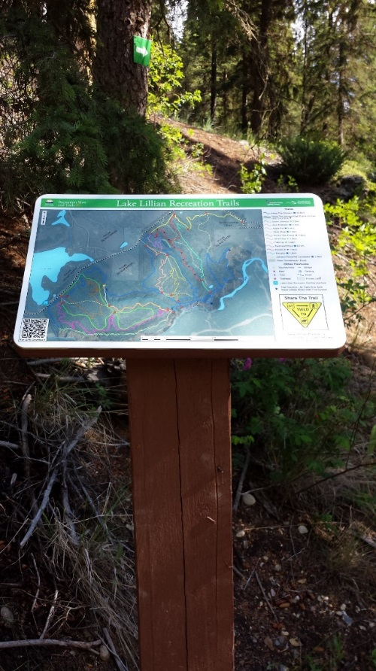
Trail Etiquette
- Keep right. Move off the trail wherever possible for less mobile trail users.
- Stay on the trail don’t short cut.
- Hikers, runners and bikers should always yield to horses.
- Bikers should yield to hikers and runners
- Downhill traffic should yield to uphill traffic.
- When approaching others from behind, a friendly greeting does wonders to let others know you are coming and common courtesy will always go a long way!
- Don’t litter.

Figure 3: Standard Trail Etiquette

Figure 4: Typical Trail Intersection Sign

Adjacent Landowners/Stakeholders
As with any development project that impacts the land, it is important communicate with adjacent landowners and affected stakeholders about the proposed project and discuss areas of potential concern. CVCS members have taken a very proactive approach to adjacent landowner and effected stakeholders of the proposed Barbour Rock Recreation trail development by actively connecting with all adjacent land owners and various stakeholders such the Crown tenure holders. To date excellent feedback has been received from the all of the contacted individuals, organizations and stakeholders. Comments have not all been supportive of the proposed trail system or mountain biking in general, but all comments provided constructive and useful comments that resulted in several changes to the initial trail concept and clearly identified areas of concerns, various issues and stakeholder operations requirements. A summary of the feedback received from theses one on one conversations and CVGTA/CVCS responses are listed in the Appendix C. CVGTA and CVCS received many letters of support over the past year, notable letters came from the Summit Trail Makers Society, the Radium Chamber of commerce and the Columbia Valley Chamber of Commerce. These organizations see the huge benefits of adding these trails to the valley. Their letters are attached in Appendix ‘D’.
CVGTA and CVCS has welcomed all input and suggestions on the proposed Barbour Rock Recreation trails so as to ensure the best trails possible that will not only offer an epic recreation trail, but one that respects the land, adjacent land owners, stakeholders and Crown tenure operators.

General Public Input and Consultation
As is typical of applications with the Ministry of Forest, Lands and Natural Resource Operations for use of land, the application goes through a circulation process to various other Ministries within the Provincial Government as well as to the local Regional District, in this case the Regional District of East Kootenay (RDEK). The CVGTA and CVCS were invited to present at the RDEK Areas F & G Advisory Planning Commission (APC) meeting on November 15, 2016 the proposal for the Barbour Rock Recreation Trail System. The Commission members had some excellent questions and concerns which required further work on the plan by the CVGTA, CVCS and RSTBC.
Questions as listed in the RDEK Areas F & G APC Minutes
- What are the widths of the trails?
- Will the trails be built by hand or machine?
- Is there a real need for more recreation trails?
- Has there been a wildlife study?
- Has there been communication with stakeholders?
- What are the standards for building trails?
- Who will use the trails?

The Commission concluded with a non-support at that time as they felt more public consultation was needed as well as additional input from a Biologist on the impact of recreation trails on wildlife. The referral onto the RDEK Planning and Development Committee was postponed indefinitely to give the CVGTA, CVCS, and RSTBC time to address the Commissions concerns.
With the input from the Commission, CVGTA, CVCS, and RSTBC determined that more work had to be done to address the concerns surrounding potential impacts to the environment and to do more public engagement with the general public. A second report was commissioned by a local well-respected biologist, Ms. Eva M. Boehringer, MRM, RPBio. Ms. Boehringer was asked to address specific concerns identified by the local BC Environment office on the proposed trail design and alignment and how to mitigate or avoid negative expertise. Attached as Appendix “D” is Ms. Boehringer’s report.
“Wildlife Assessment and Recommendations for the Proposed Barbour Rock Recreational Trails”, January 2017 - Prepared by: Eva M. Boehringer, MRM, RPBio

The CVGTA and CVCS appreciate the BC Environment office’s expertise in identifying areas of potential concern and Ms. Boehringer’s work to ensure the trail design and alignment properly addresses these concerns. The CVGTA and CVCS now feel confident that the trail can be designed and constructed so as to avoid all potential fragile areas, or work around them to manage the impact (how and where to build bridge structures), and the continual monitoring and awareness of wildlife in the area and how to avoid negative interactions and impacts.
The answers to the RDEK APC Members questions can be found on the pages listed after each question:
Answers to RDEK Areas F & G APC Member Questions:
- What are the widths of the trails? Pages 22 & 23
- Will the trails be built by hand or machine? Pages 27 & 28
- Is there a real need for more recreation trails? Pages 18 & 19
- Has there been a wildlife study? Pages 15 & 17
- Has there been communication with stakeholders? Pages 27 & 28
- What are the standards for building trails? Pages 27
- Who will use the trails? Pages 15

RSTBC commissioned a ‘Preliminary Field Reconnaissance Report’ to review the area for potential culturally significant features. Which concludes that there are no known sites of cultural significance in the subject area. The report does recommend that there is potential for “Areas of High Archaeological Potential (HAP)” on the entirety of the top summits”. Consequently these areas should be subject to subsurface testing to confirm or refute the presence of archaeological materials prior to the construction of a trail. This will affect both the mountain biking sections and the hiking sections. This report can be found in Appendix ‘H’.

Public Information Open House
Not only did the CVCS continue to actively solicit input and comments on their website, www.columbiavalleycyclingsociety.org several articles were placed in the local newspaper, Columbia Valley Pioneer and two Public Open House information events were hosted by the CVGTA, CVCS and RSTBC on January 20 and 21, 2017. Over 170 people took time out of their busy schedules to attend the public open house events. Ninety-two (92) attendees helped us out by completing a comment form to provide written feedback on the Barbour Rock Recreation Trails system proposal. Of these comments eighty-two (82) were in full support of the proposal; five (5) expressed support with conditions; and, five (5) were against the proposal. The five expressions of support with conditions listed concerns about user conflict issues that they hoped would be considered and addressed, including concerns about the climbing area and the need to protect the access and safety of the climbers. The five comments received indicating they were against the proposal also mentioned the following concerns:
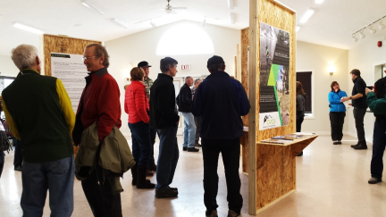
- user conflict;
- the climbers want peace and quiet;
- there are already too many people on the trails in the area;
- is there really a need for more trails; and
- environmental concerns.
A selection of comments received is provided on the next page in Figure 4. All of the comments received at the Public Open House information events are attached as Appendix “E”.
The CVGTA and CVCS have undertaken extensive time and effort to address the concerns and issues brought forward during the initial conversations with adjacent landowners and affected stakeholders, the feedback from the RDEK Areas F and G APC members, Ministry of Environment and all comments received at the two Public Open House information events.
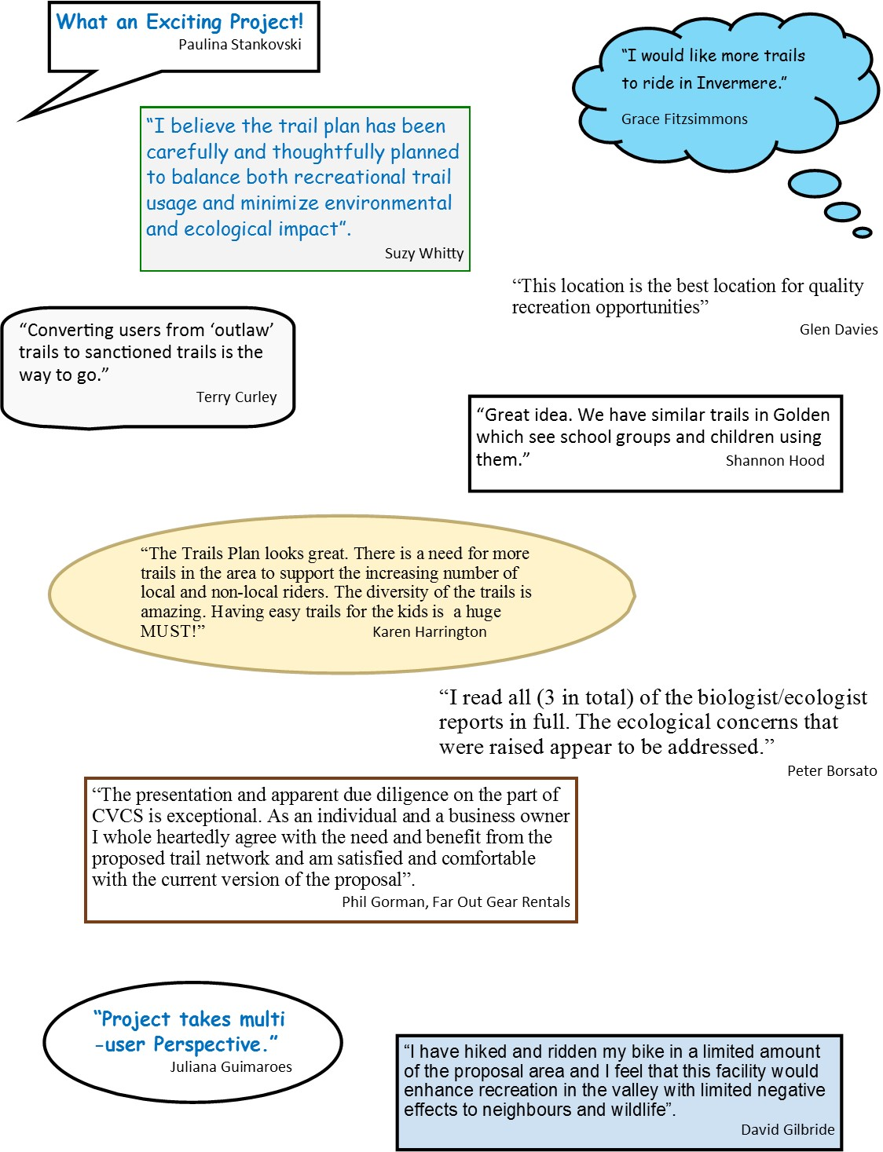
Figure 4: Selection of Open House Comments
Selection of Open House Comments

5. Trail Design
The design and construction of a trail greatly impacts the long-term success and maintenance requirements of a trail. To date hundreds of hours have been put into planning the proposed Barbour Rock Recreation trail system in an effort to create a well-crafted, unobtrusive, environmentally sensitive trail system that will be fun and exciting to use.

Trail Standards
By using RSTBC mountain bike trail standards in designing, building and maintaining the Barbour Rock Recreation trail system although with industry best practices, safe, enjoyable recreation trails will be built. Using this standard will provide protection for the surrounding environment while respecting the adjacent landowners and stakeholder interests in the land.
The RSTBC standards control trail width, trail surface, grade and drainage methods. Different types and uses of recreation trails have different trail characteristics as can be seen in Table 1 below. Type I trails are designed for heavily used trails in highly populated areas and have the most impact on the environment. Type V on the other hand sees the least amount of traffic, is narrow, usually built for a specific use and extreme difficulty level. These trails with their unique characteristics have the least impact on the environment.
Table 1: Trail Type Characteristics

Trail Type | Characteristics
Type I | - A paved double-track trail for smooth, all weather use in communities or parks  - Trail surface is asphalt or chip-seal coat  - Clear trail width of 2.0 – 3.0m plus 0.6m gravel shoulder with adequate drainage infrastructure  - Clear trail height of 3.0m  - May include illumination for night use  - May include interpretive sites, benches and viewing areas
Type II | - Either a double-track or single track trail  - Usually machine built  - Smooth with all embedded obstacles removed  - Surfaced with crushed limestone with fines, well-compacted gravel or existing old road bed  - Clear trail width of up to 5.0m for double-track with 2.0 – 3.om tread width and 1.6m clear trail width for single track with 1.0m for tread width  - Clear height of 2.4m  - Possible illumination for night use
Type III | - An unsurfaced single track trail  - Clear trail width of 1.1 to 1.3m with approximately 50 – 70 cm as tread width  - Clear trail height of 2.4m
Type IV | - An unsurfaced single track trail  - Clear trail width of 1.0m with approximately 30 – 50 cm as tread width on native soil including some rough terrain  - Clear trail height of 2.4m
Type V | - A low-impact natural trail or lightly used wilderness trail  - No high impact users such as motorized or horses  - Provide 30 – 50cm of tread width maximum; avoid tread grubbing, could include sections of very rough terrain  - Clear height of 2.4m
Rating trail difficulty depends on the specific trail use, is very subjective and based on a number of variables, including: the anticipated fitness and attitude of the trail user. Trails for mountain biking for example are rated using terrain, grade, distance and if Technical Trail Features (TTF) are present. Generally, the user difficulty level increases with the Trail Type listed on the previous Table. Beginner level can be found on Green circle type trail (Trail Type I to II) all the way up to Expert level on Black diamond trails (Trail Type V). See Table 2 for details. The Barbour Rock Recreation trail system is proposing to include trail in the mountain biking sections in the Type II and Type III trails range for beginner to advanced intermediate riders.
Table 2: Trail Rating Designation
MOUNTAIN BIKE TRAIL RATING DESIGNATIONS | GREEN CIRCLE (Easy) | BLUE SQUARE  (More Difficult | BLACK DIAMOND  (Most Difficult) | DOUBLE BLACK DIAMOND  (Expert Unlimited)
APPROPRIATE USER | Beginners and Recreational Riders, Mountain Bikes recommended. | Intermediate Riders. Increased challenges and difficulty. | Advanced/Expert Riders. Difficult and technical challenges. High level of fitness required. | Expert Riders Only. Most difficult and technical challenges. Highest risk level.
TRAIL DESCRIPTION | Gentle slopes and easily avoidable obstacles such as rocks, roots and potholes. | Challenging riding with steep slopes and/or obstacles, narrower trails with reduced traction. | Mixture of long steep climbs and descents, loose trail surfaces, numerous difficult obstacles to avoid or jump over, drop-offs and sharp corners. Some sections easier to walk than ride. | Exceptional bike control skills and balance essential to clear many challenging obstacles. Higher risk level. Some sections easier to walk than rider.
TYPICAL TRAIL TYPE | II – III | III – IV | III - V | III - V
FEATURES | Embedded trail obstacles up to 10 cm high. | Embedded trail obstacles up to 20 cm high. | Embedded trail obstacles may exceed 20 cm high. | Embedded trail obstacles may exceed 20 cm high.
MINIMUM WIDTH | 1.0m | 0.5m | 0.3m | 0.3m or less
TRAIL SURFACES | Primarily soil and small loose rock, occasional screening. | Rough natural terrain and increased rock and root debris. | Rugged natural terrain. May include some TFF’s | Rugged natural terrain. Includes TFFs.
AVERAGE GRADE | 8% | 10% | 15% | May exceed 15%
MAXIMUM GRADE | 15%, except rock faces at 25% | Climbing – 25%, Descending - 35%, Rock Surface -45% | Climbing – 35% | May exceed 35%
MINIMUM CURVE RADIUS | 2.4m | 1.8m | Sharp corners | Sharp corners
EXPOSED NATURAL OBSTABLES (MAX. HEIGHT) | 10cm max. height. Occasionally higher height for highly visible, easily avoidable obstacles. | 20cm max. height | Various heights, some exceeding 20cm | Various heights, some exceeding 20cm
BRIDGES (MIN. WIDTH) | Min 1.0m | Min. width of 50cm. Flat decking is minimum one-half the height above surface. | Various widths. Min. 30cm. Flat width of decking is one-quarter the height above surface. Elevated bridges less than 3.0m high above surface. | Same as Black Diamond.
TECHNICAL TRAIL FEATURES (TTFs) | Small roots and logs to cross, embedded rocks to avoid. | Small bridges (flat, wide, low and rollable from section to section). Small rollable drops. Medium sized logs. | Elevated bridges. Connected bridges. Larger jumps. Steep descents with sharp transitions. | Most difficult. Exceeds Black Diamond TFFs.
ROCK FACE OR RAMP DESCENTS (MAX. ANGLE) | Rock face descents not to exceed 25% grade. | 45% | Not to exceed 120%. | May exceed 120%
DROPS (MAX.HEIGHT) | None | Drops up to 30cm, with exit cleared of all obstacles. | Drops greater than 30cm. Some mandatory air. | Mandatory air.
JUMPS (MAX. HEIGHT) | None | 45cm no jumps with consequences for lack of speed. | Table tops, no maximum height. | Same, except may include gap jumps.
TTFs are obstacles on the trail, either natural or manmade that add a degree of difficulty to the trail. A structure on the trail installed for user safety or protect the environment, such as a bridge or boardwalk, is not considered a TTF. (RSTBC, 2013)

Trail Alignment
The final alignment and location of each portion of the Barbour Rock Recreation trail system will ultimately be set during the construction stage as the terrain will dictate the final trail alignment and location. This may result in a slightly different alignment than what is shown on the proposed trail map (Appendix ‘B’). The trail construction portion of the project will set the exact alignment to take advantage open lines of vegetation and avoid environmentally sensitive or dangerous features. Existing micro-soil conditions will also be considered in the trail alignment position.
The cross-country mountain bike trail section will be design to wind and flow with the terrain. The downhill portions of each mountain bike trail will be constructed using industry standard special trail building techniques that foster controlled downhill speeds. These include: winding the trail down the hill with no straight downhill runs; adding small uphill turns at the bottom; and, the use of berms around corners to reduce skidding which leads to degradation of the trail.
The Barbour Rock Green trail, is proposed to be approximately 3 to 4 km in length and located close to the Toby Creek Road in a figure eight configuration. This trail is designed as a multi-use, Type II trail. Grades will be kept as low as possible maxing out at 15% and having a trail width of approximately 1.0m. This trail will see a variety of mountain bike levels and abilities along with other non-motorized trail uses moving in two directions on the trail. The Green Trail is the focal point of the Barbour Rock Recreation trail system as all other trails sections connect directly to or loop back onto it. The main trailhead is located at the intersection of the figure eight of the Green Trail.
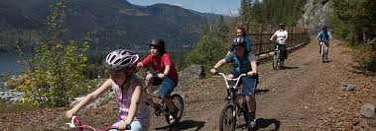
The east loop of the (the east side of Bear Mountain FSR) is proposed to be approximately 10 km of the 30 km plus complete trail. The trail officially begins at the eastern edge of the Green trail. The East Barbour Rock trail is made up of undulating intermediate (Blue) level mountain bike terrain. The trail uses an existing single track trail and passes close to the north end of Lake Lillian up on a ridge. Neave creek is proposed to be crossed twice. The southern crossing is over an existing small bridge structure that was built for a previous international mountain bike race. The second crossing will require a new bridge structure to be built. The final design and length of the bridge will depend on the exact location of the crossing which will be determined in the field to keep the crossing well away from the wildlife watering hole and not in an area that will damage the creek banks (VAST Resource Solutions, 2016). After crossing Neave Creek for the second time the trail loops back to the Green trail meandering through the open forest with twists and turns, uphill’s and down. This trail will be built primarily as Type II or III. The ability level is anticipated to be blue (intermediate) level riders; that is: similar to what currently exists on the Johnson Trail in the Lake Lillian trail system.

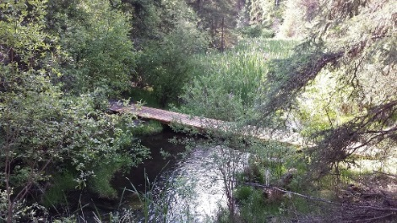
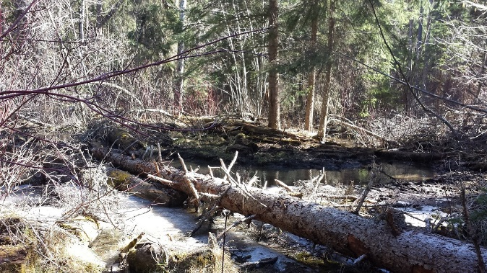

SECOND NEAVE CREEK POTENTIAL CROSSING LOCATION, showing potential bridge structure and how it would fit in with the terrain

The longer, showcase, west loop of the Barbour Rock trail (west side of Bear Mountain FSR) is proposed as the signature single track cross-country mountain bike trail. This trail proposed to provide trail users opportunities to summit one, or all five peaks on the ridges of Barbour Rock. This trail loop can be ridden as one long ride or broken up into shorter rides looping back onto the Green trail. Riders will come upon a number of long uphill climbs and curvy downs. Breath-taking views of the Columbia Valley are the reward for those trail users who reach the summits and stop to take it all in. The trail is intended to be ridden in both directions, although one way may become more desirable then the other. The trail will be built as a Type II or Type IV standard trail and will be appropriate for the more experienced blue (intermediate) level riders as there may be some ‘black’ or expert level sections on the trail.
The hiking-only (foot traffic) trails near Barbour Rock will branch’s off at the western extent of the Green trail near the Barbour Rock crag. These narrow hiking designed trails will also provide opportunities to summit the highest ridge Barbour Rock primarily from the front side. The trail will be designed to follow the terrain and be approximately 2 to 3 km one way.
During the initial Barbour Rock Recreation trail planning, some consideration was given to developing a boardwalk trail along the west shoreline of Lake Lillian as a link to the Lake Lillian Recreation Trail system. Unfortunately, the environmental considerations were such that the CVCS felt it was outside their ability or interest to undertake this challenge. It was therefore removed from the proposal. Currently, no link is proposed between the two trail systems at this time.

User Considerations
The Barbour Rock Recreation trail system intends to provide exciting experiences for all trail users; from families hiking or biking together to advanced cross-country trail riders. On the mountain bike riders’ trails are proposed to get progressively more difficult the further from the trailhead the trail loop is. Each trail has been proposed to offer challenging experiences for some, excitement for all and beautiful views all around.
As with all recreational trails there can be safety concerns and the activities of mountain biking, climbing or hiking can be dangerous, the Barbour Rock Recreation trail system and the proposed uses will be no different. The trails will be designed and constructed so as to not put any user into an extremely dangerous situation that can be avoided. In the rare instance where the trail must go close to a potential dangerous spot, signage or barriers will be placed to warn trail users. In the unfortunate event of an accident, the Barbour Rock Recreation trail system is in the enviable position of having public road access on all sides of the trails which can be used by emergency vehicles for assistance or extraction. The looping design of the trail brings it close to the roads in several locations offering ‘outs’ every few kilometers. The trail system is also completely within cell range if help is needed.

Parking / Trailheads
Trailheads are necessary to provide a base or staging area for the trail. The Barbour Rock Recreation trail system layout has been designed with a well-defined trailhead to give all users trail orientation and organization. The parking area / trailheads proposed for the Barbour Rock Recreation trail system is directly off the Toby Creek Road using the existing BC Hydro right-of-way driveway to access the parking area. Space is currently proposed for approximately 20 vehicles.
The trailhead area will not only include a parking area, but with a kiosk as well. Outhouse facilities may be included and possibly picnic tables at RSTBC direction. The trailhead kiosk will be of the same design as the Lake Lillian Recreation Trails kiosk. The trailhead kiosk has a large trail map and the following information:
- Trail use rules and etiquette (e.g. Keep all dogs under control; and, reminders that this is a multi-users trail)
- Crown tenure holders Information (e.g. you are in an active Christmas Tree Harvesting area).
- Emergency contact information (911).
- Contact information for trail maintenance concerns (CVCS).
- Acceptable trail user groups (non-motorized on trails only).
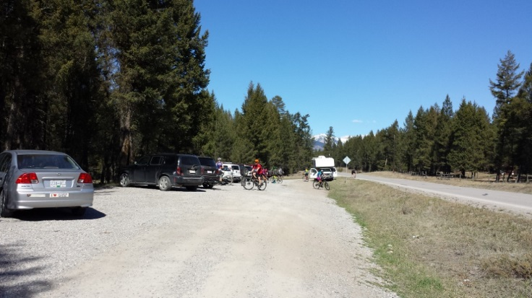
Existing Lake Lillian Recreation Trails Parking Area

Signage
The Barbour Rock Recreation Trail system will implement the RSTBC standards and guidelines for all signage as is required on sanctioned recreation trails in the Province. These standards set the type, size and style of signs. All of the signs proposed for the Barbour Rock Recreation trail system intend to enhance the trail user’s experience, direct users away from sensitive or fragile areas, highlight special or unique features as well as protecting the rights of the other Crown tenure holders (BC Ministry of Forests Lands and Natural Resource Operations, p. App 6).
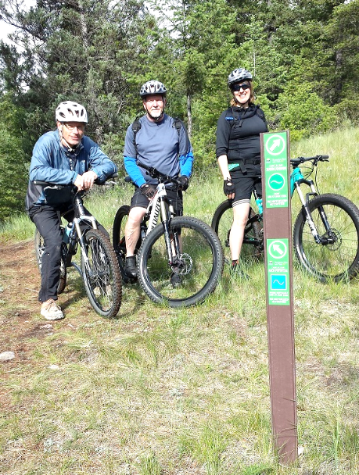
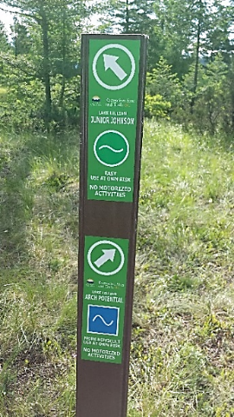
As recognized by the CVGTA Trails Vision-2017, planning for good signage is challenging. Each situation must find the balance between the number of signs needed for effective trail use, and the protection of the viewscape from the trail. If too few signs are installed trail users have problems direction finding and potential safety concerns and user conflicts may arise due to lack of knowledge or understanding of the area. The intention for signage on the Barbour Rock Recreational trails is to continue using the very successful direction (Figure 11) and ‘You Are Here’ (Figure 12) signs currently used on the CVCS sanctioned Lake Lillian Recreation Trails. These signs have extensive trail information about the ability level of the trail, which way to go for a particular trail and a reminder for acceptable types of trail use. The direction signs are proposed be installed at every trail intersection, with the ‘You are Here’ signs placed at strategic locations as needed.
Figure 11:
Example of RSTBC Directional Signs

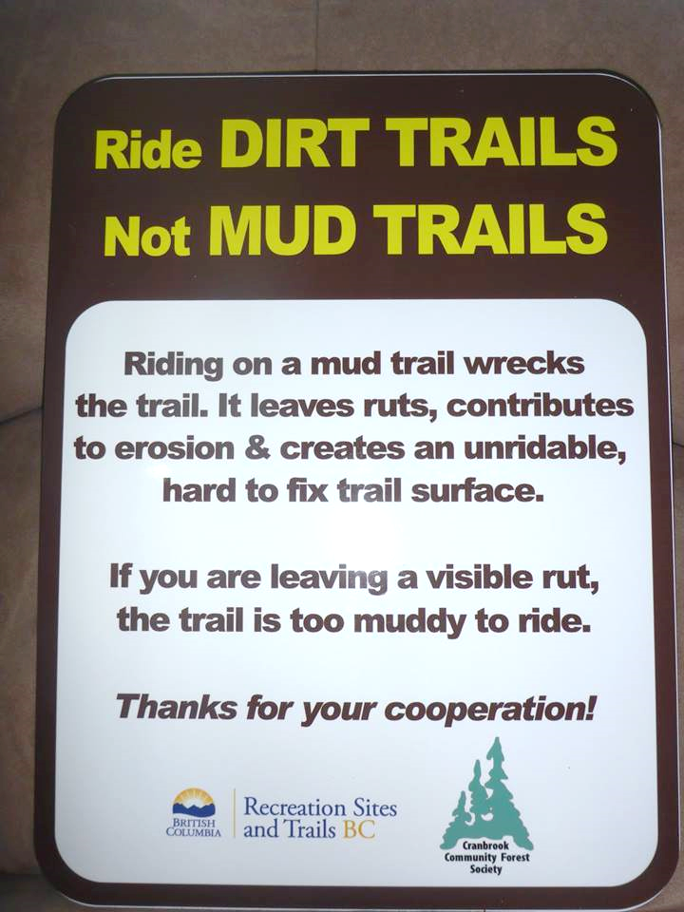
It is recognized that the Barbour Rock Recreation Trails system may require temporary signs on occasion to assist in the management of the trail. Examples of when temporary signs would be required are the following:
Figure 13:
RSTBC Example Managing Use Sign.
- To address safety concerns. Signs will caution trail users of dangerous situations;
- To remind users of permitted and not permitted activities on the trail (non-motorized only);
- For notifications to the trail users there are temporary changes to the trail system. Such as: wildlife concerns, or ongoing commercial activities (logging, etc.); or,
- When trail conditions have changes; such as mud or flooding (See Figure 13: RSTBC Example Managing Use Sign)

5. Trail Construction
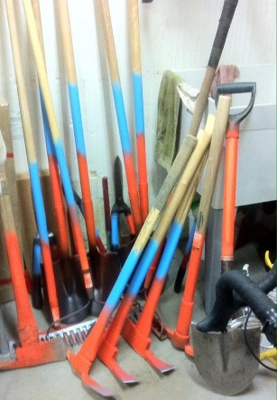
As previously mentioned all construction work on the Barbour Rock Recreation trail system will follow the standards and requirements of RSTBC. In general the trails will be built using trail construction best practices to avoid among other things drainage problems which are the most common reason that trails and surrounding area are damaged. Trail construction on the Barbour Rock Recreation trail system will be a combination of machine work and hand tools. Machine work will take place on the majority of uphill portions of the trails as this ensures proper grading and drainage in areas that would be difficult to accomplish with hand tools. The CVGTA has acquired a trailer especially outfitted for trail building activities by member groups such as the CVCS. The CVCS will be happy to take advantage of this trailer and these hand tools.

Figure 14: Examples of Typical Hand Tools used for Trail building and maintenance

The west Barbour Rock trail loop will be aligned and constructed using existing open lines between the trees so that little to no vegetation need be removed (Figure 5: West Loop Open Forest). This method minimizes any soil disturbance and meets the sustainable trail definition. On any side hill the trail technique will be done so as to minimize any cuts and fills to protect the existing vegetation and optimize natural drainage. When trails are built that disregard the natural terrain and subsequent drainage patterns, trail construction and maintenance costs are higher something the CVGTA and CVCS would like to avoid. A professional trail builder will be brought in to assist the volunteer workers with the heavy lifting portion, as well as to assist in completing the trails in an efficient and timely manner.

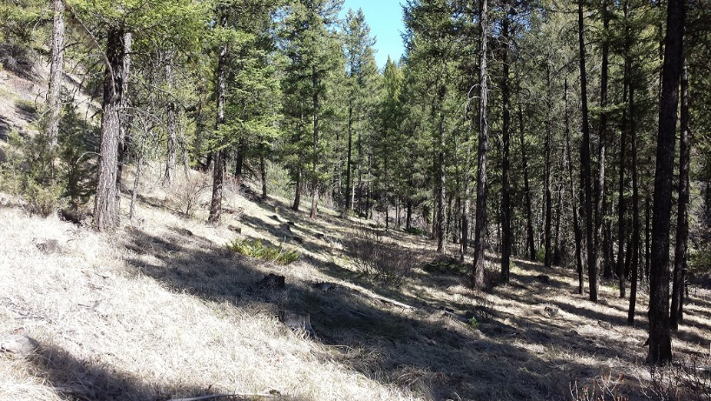

Figure 5: Potential Location of West Loop through an Open Line in the Douglas Fir Forest
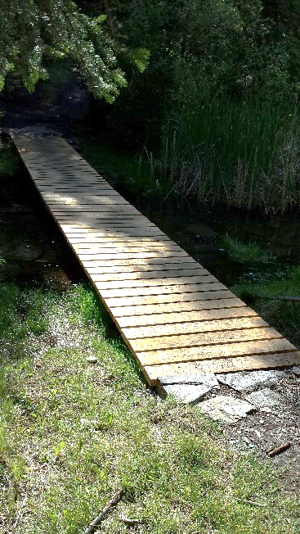
At this time no TFF’s are proposed on any of the trail sections in the Barbour Rock Recreation trail system. All proposed bridge construction will follow the standards set by RSTBC to ensure the safety and comfort of trail users as well as protecting the sensitive riparian areas during construction and future trail use. The bridges will built in a similar manner as the bridges on the Johnson Trail of the Lake Lillian Recreation Trails (Figure 6 below). These wooden bridges have tightly spaced deck rungs that are designed to avoid anyone falling through while still allowing drainage off the bridge structure. A safe and appropriate bridge width keeps trail users from riding or walking through the creek or into sensitive riparian areas.
Figure 6: Bridge Construction Specifications

6. Maintenance
Trail maintenance is an integral component of managing trails. As stewards of the trails the CVGTA, CVCS and all trail users provide an effective level of protection to the environment by simply using the trail. Undesirable activities on and around the trails are discouraged by the very presence of trail users. The trail users will become the eyes and ears of the area noticing any unauthorized activities, such as camping and unattended campfires and can ensure a quicker response time to address these harmful activities.
By keeping the Barbour Rock Recreation trail system in as excellent shape as possible the Greenways Trail Alliance and CVCS members and all trail users will continue to enjoy and benefit from the trails now and in the future.
Annual trail inspection and maintenance will occur on the Barbour Rock Recreation trail system. Generally trail maintenance will include the list below in Figure 18: Trail Maintenance Activities. Checking for invasive species appearing in and around the trails will also be included in the maintenance activities. Most importantly volunteers will be looking to address any drainage or erosion problems on the trails. As required annual reporting in writing will be provided to RSTBC on trail and structure inspection activities and results, and any maintenance activities undertaken.
A well maintained and cared for trail helps to promote good behaviour among trail users.
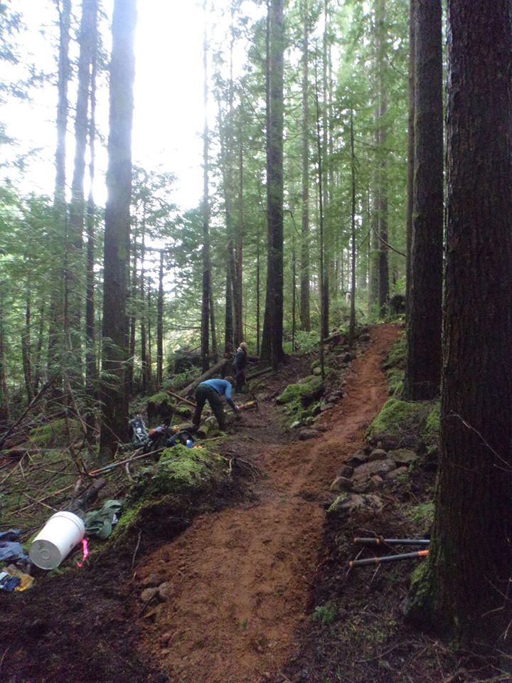
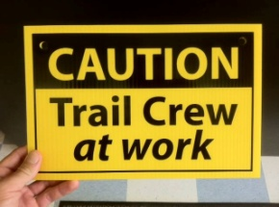
Example of Trail Maintenance Requirements
1. Deadfall – Cut out all blowdown/deadfall over the trail, remove wood a minimum of 0.5 metre from the tread centre and dispose downhill when possible.
2. Brushing – Remove all juvenile trees and woody brush for 0.5 metre on either side of tread centre within 3 centimetres of ground level. Scatter the cut material out of sight of the trail.
3. Limbing – Remove tree limbs to allow 2.5 metres of overhead clearance above the trail, with 1.0-1.5 metres total clearance width. Scatter cut limbs a minimum of 3.0 metres from the trail edge, out of sight where possible. Ensure limbing cuts are clean, without scarring the main trunk of the tree.
4. Tread surface – Ensure the tread surface of the trail provides a stable walking surface of not less than 40 centimetres in width.
5. Erosion control – Clean and repair any existing water bars, culverts and ditches as necessary to drain water away from the trail and prevent erosion.
6. Route marking – Mark obscure routes with cairns or delineating tags as required.
7. Litter cleanup – Remove litter and garbage at the trailhead, along the trail, and at any associated camping areas.
8. Trail sign maintenance – Conduct minor repairs as required, such as resetting posts and ensure signs are secure.
Figure 18: Example Trail Maintenance tasks
Figure 17: Volunteer Trail Crews at Work

7. Proposed Budget
The proposed budget for the development and construction of the Barbour Rock Recreation trail system is approximately $250,000 to $300,000 made up of volunteer effort, donated materials and equipment as well as purchased items and professional assistance.
 |  | Approximate Amount
Trail Construction | $6/lineal m over 30-40km | $180,000 - $240,000
Parking Lots/Trailhead |  | $20,000
Signage |  | $10,000
Miscellaneous |  | $30,000 - $40,000
 | Proposed Total Budget | $250,000 - $300,000
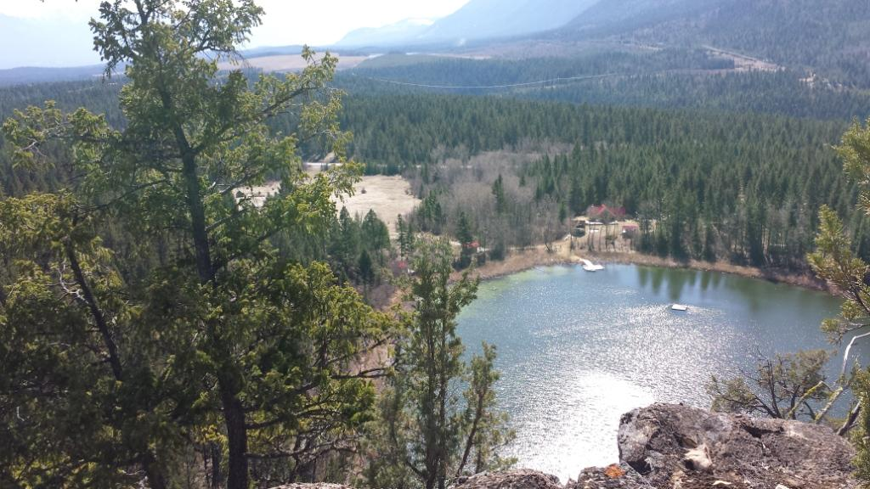
CVGTA and the CVCS will raise the money necessary to complete the project through fund raising activities, membership drives or applying for grants. RSTBC will continue to provide guidance and expertise for the recreation trail construction and maintenance.
Barbour Lake

8. Future Intentions for Trails in the Area
The CVGTA has recently completed the Trails Vision-2017 for the Columbia Valley region. The Vision document is a strategy that provides the region with a long term community vision for trail-based recreation and establish clear direction on future trail development. The Barbour Rock Recreation Trail system is included and supported in this Vision document.
A goal of the CVGTA Trails Vision-2017 is to provide opportunities and direction for trails that will ultimately link the Columbia Valley from Canal Flats to Donald and all of the communities in between for non-motorized forms of transportation.
The CVGTA Trails Vision-2017 (McElhanney Consulting Services, 2017) identifies areas for potential future trails in the Toby Benches area and beyond. The Vision document suggests that a recreation trail link be developed between the existing Lake Lillian Recreation Trail system, the proposed Barbour Rock Recreation Trail system and Lake Enid. A future recreation trail link is also proposed from the District of Invermere all the way up to Panorama which may include a bridge over the Toby Creek at a location to be determined.
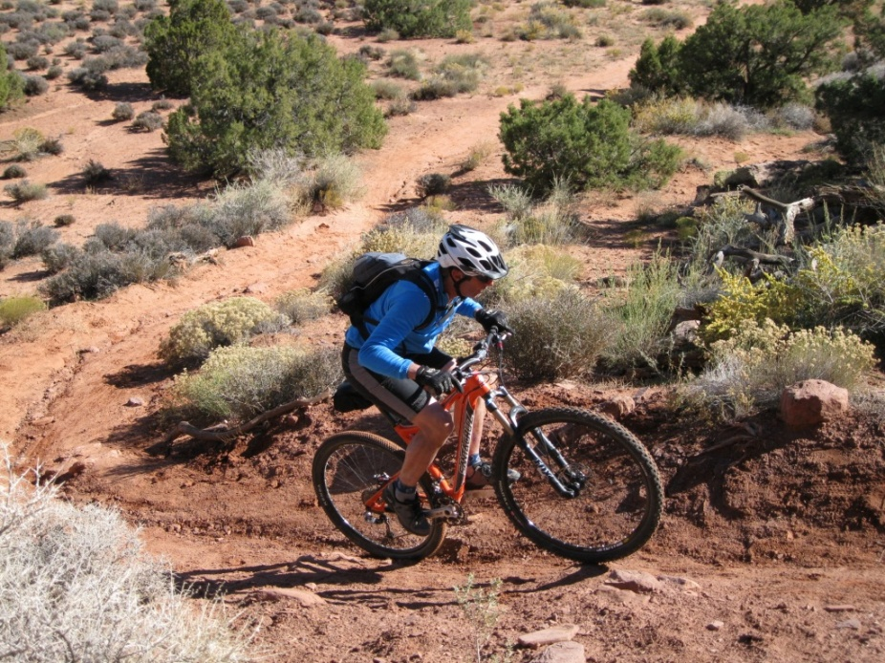

9. Conclusion
The proposed Barbour Rock Recreation trail system will be an epic adventure that can be hiked, biked or run as one long trip or broken down into a manageable distance using one of the shorter loops. This proposal for sanctioned authorized recreation trails on Crown land to move recreation trail development in the Columbia Valley towards trails effectively managed and maintained. Locals and visiting recreation trail users will rejoice with the addition of exciting and quality recreation trails in the area. The design and construction methods of the trail system will follow RSTBC standards to ensure adequate safety, environmental protection and provide an enjoyable experience for all trail users. The recommendations presented by VAST Resource Solutions and Ms. Eva M. Boehringer, MRM, RPBio will be integrated into all of the trail construction as they highlight the viability and sustainability of the trail system.
CVGTA and CVCS have worked diligently to address the issues and concerns expressed and presented through the community and stakeholder consultation. The trails have been located as far away from private lands and environmentally sensitive areas as possible in respect for the adjacent landowners and the environment. The trails design and construction methods will limit soil disturbance by incorporating existing and old roads, tracks and trails where appropriate, and, reusing existing bridge structures so as to reduce any unnecessary access driveways will be done using the sustainable methods. Annual maintenance activities will be scheduled to upgrade any portions of the trail which needing work and possibly realigning the trail section to eliminate the any future problem area that may arise.
The CVGTA and the CVCS look forward to riding, walking, running or hiking the new Barbour Rock Recreation trail with you soon.
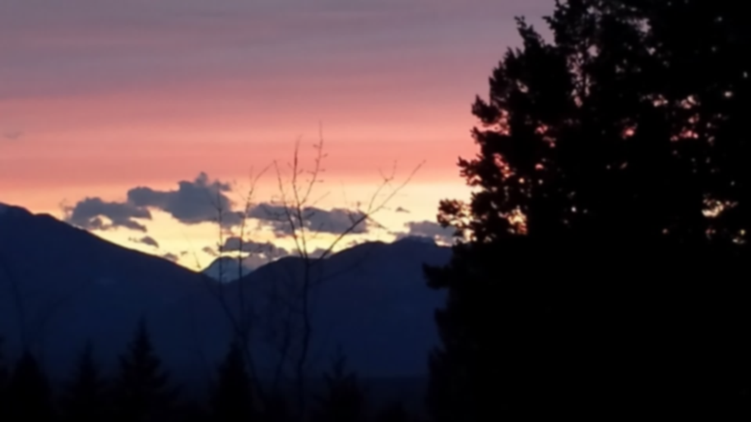

References
BC Ministry of Forests Lands and Natural Resource Operations, F. (n.d.). Recreation Manual - Appendix 6: Signs. Province of BC.
BCRPA. (2006). Strategic Plan for the Parks and Recreation Sector in BC. BC Recreation and Parks Association.
Destination BC Corp. (2013). BC Input-Output Model Report: Mountain Biking in Rossland and Golden. BC Stats.
IMBA. (n.d.). Trail Solutions: IMBA’s Guide to Building Sweet Single Track. IMBA.
Lau, L. (2014, June 7). Economic Impacts of Mountain Biking Tourism. Retrieved from Pinkbike: http://www.pinkbike.com/u/leelau/blog/economic-impacts-of-mountain-biking-tourism.htm
McElhanney Consulting Services. (2017). CVGTA Trails Vision - 2017. CVGTA.
Miistakis Institute. (2010). Mountain Biking: A Review of the Ecological Effect. Parks Canada.
Norman, T. J. (2010). CANADIAN TRAILS STUDY. National Trails Coalition.
Rec Sites & Trails BC. (2001). Chapter 10 - Recreation Trail Management. In L. a. Ministry of Forests, Rec Sites and Trails Manual. Province of BC.
Recreation Sites and Trails BC, I. (n.d.). Trail User Counts Johnson and Kloosifier 2013. Ministry of Forests, BC.
Resort Municipality of Whistler. (2003). Whistler Trail Standards: Environment and Technical Trail Features. Resort Municipality of Whistler.
Resort Municipality of Whistler. (2003). Whistler Trail Standards: Environmental and Technical Trail Features, Edition 1. Resort Municipality of Whistler.
Richards. (1991). Sustainable Trails. US National Park Service, Rocky Mountain Region.
Richards, B. (2007). Pathways to Trail Building. Tennessee Department of Environment & Conservation. Recreation Educational Services Division Greenways & Trails Program.
RSTBC. (2013). Authorizing Recreational Mountain Bike Trails on Crown Land - Operational Policy. BC: Province of BC.
TrailNet, A. (2001). TRAIL BUILDER’S COMPANION. Alberta Community Development.
VAST Resource Solutions. (2016). Vegetation Assessment and Recommendations for Proposed Barbour Trails. VAST Resource Solutions.
Weller, A. (2013). Ranches in the Windermere Valley. Windermere Valley Museum and Archives.
Whistler Trail Standards: Environmental and Technical Trail Features, Edition 1. (n.d.). Retrieved from htpp://www.mbta.ca/assets/pdfs/trail_standards_first_edition.pdf

APPENDIX ‘A’: Barbour Rock Recreation Trail System Location Map
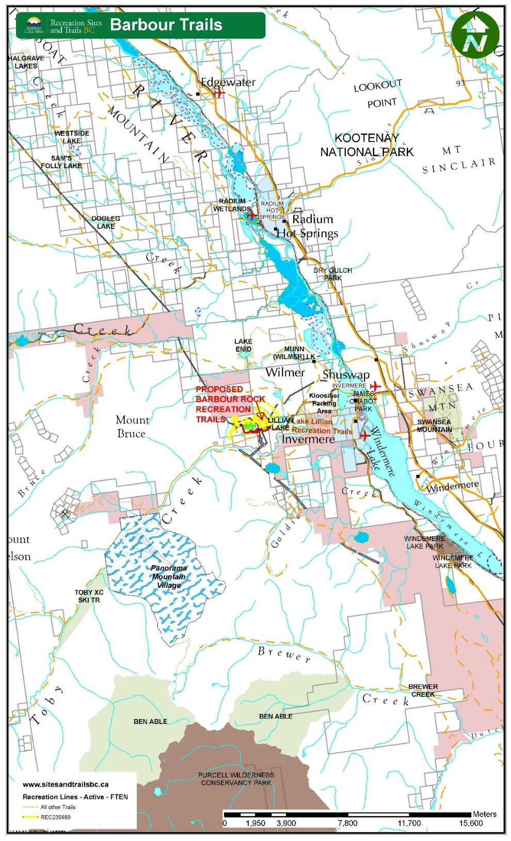

APPENDIX ‘B’: Barbour Rock Recreation Trail System Proposed Trail Map (January 2017 Version)

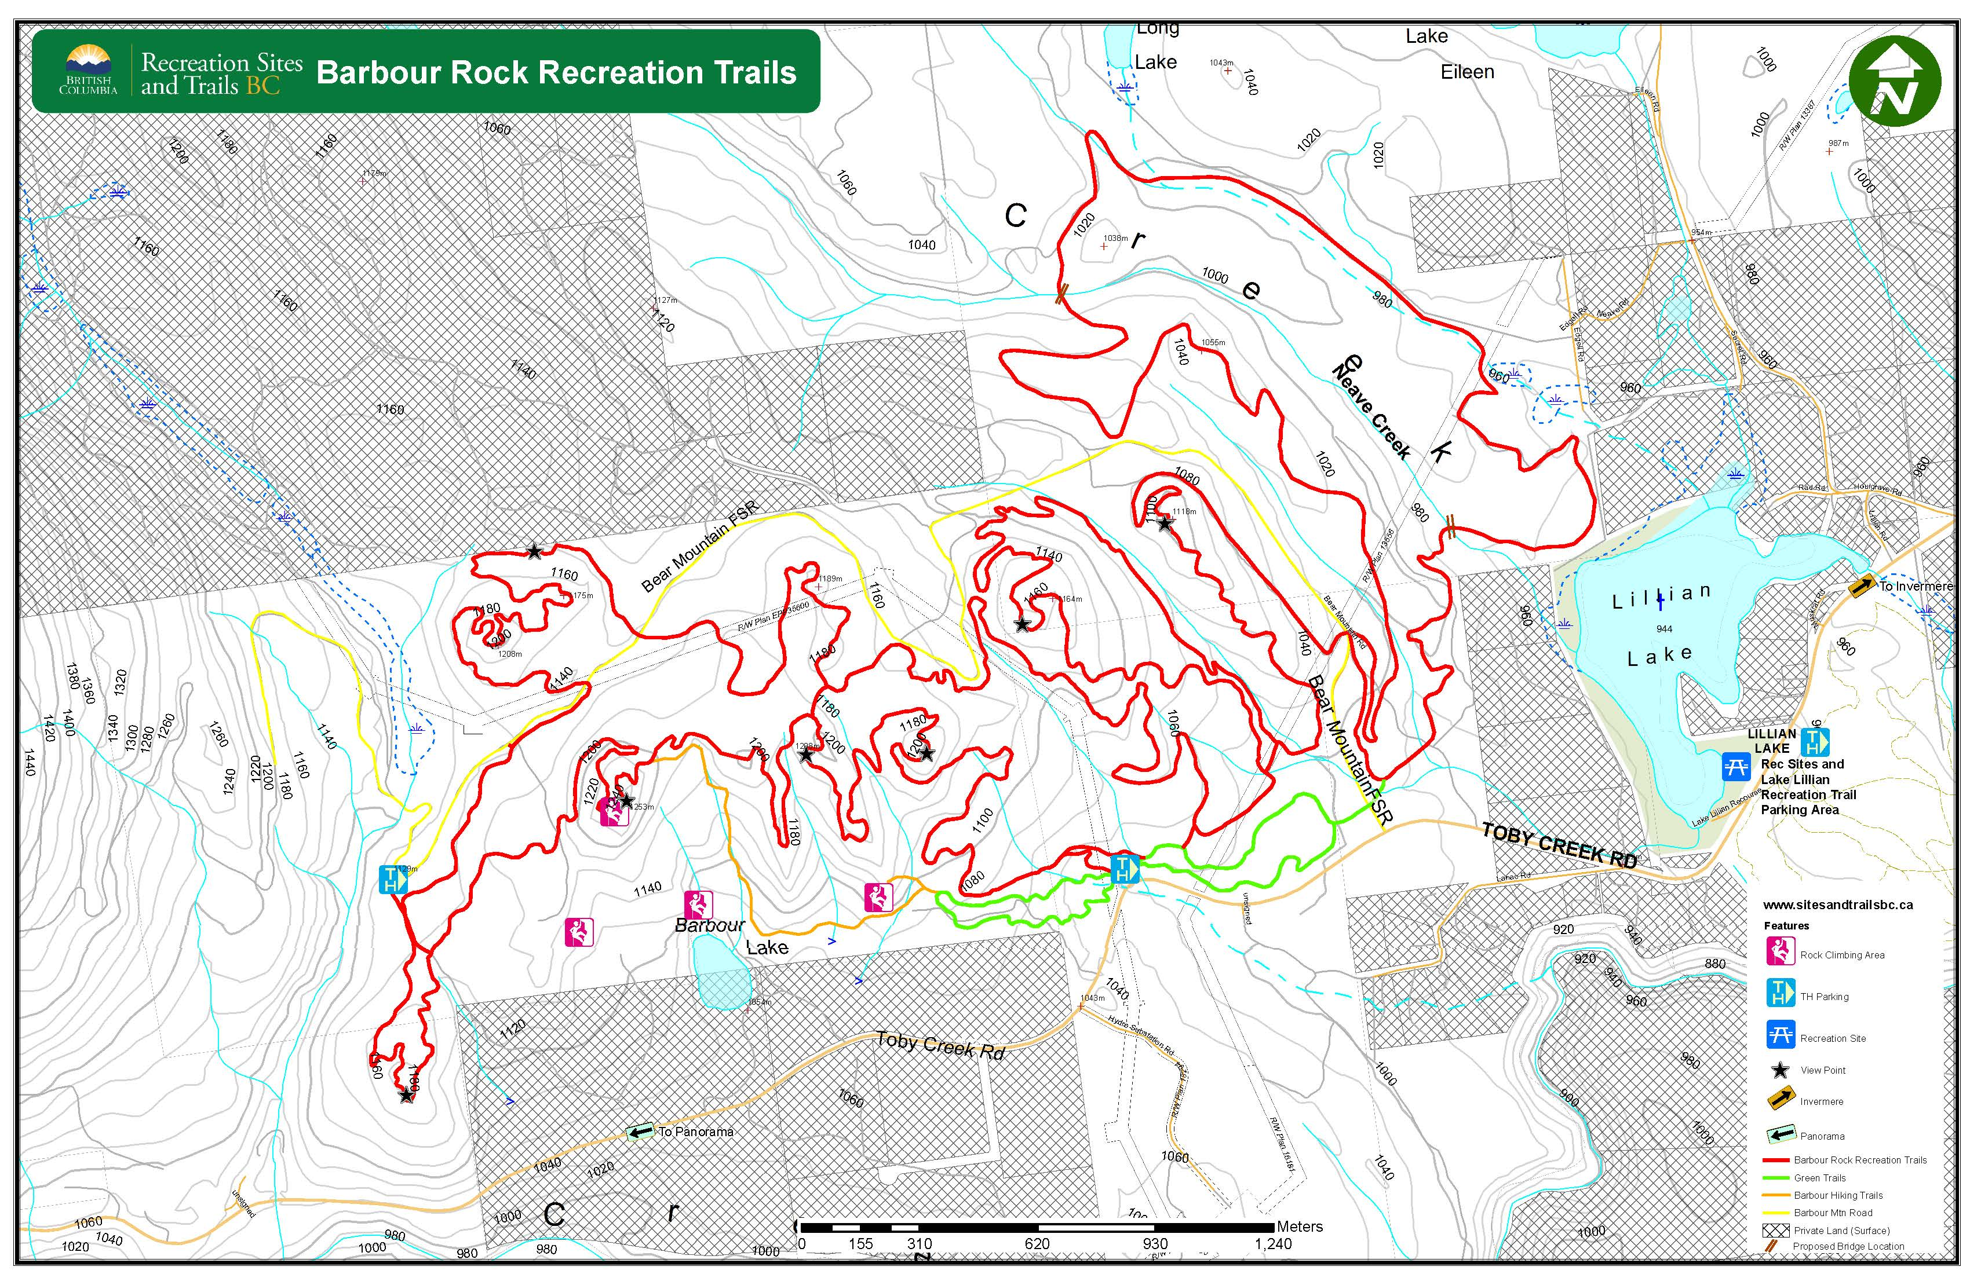

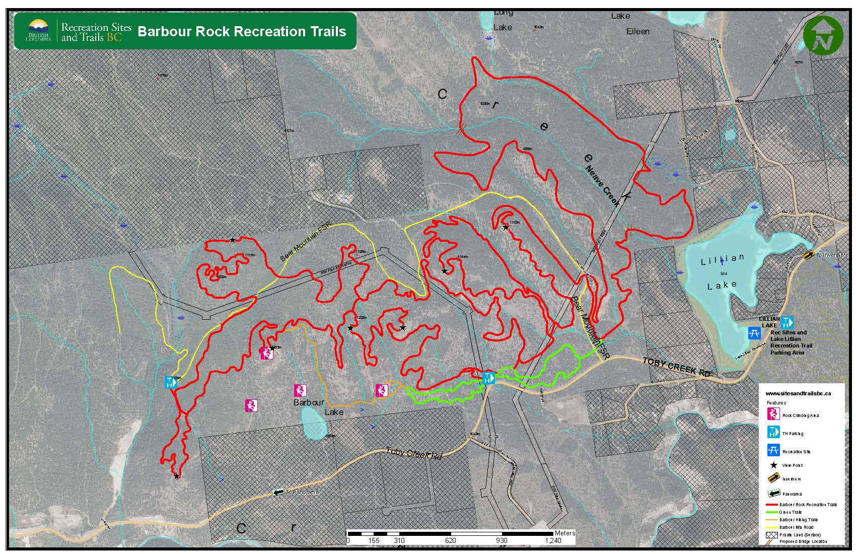

APPENDIX ‘C’: Barbour Rock Recreation Trail System Stakeholder Comments

STAKEHOLDER COMMENT / CONCERN | CVGTA / CVCS RESPONSE
concerns with “rogue” mountain bike trails that have appeared in the area over the years causing soil degradation | This is the purpose of the Trail Plan and Application for authorization and sanctioning with RSTBC. This will ensure proper design and maintenance so eliminate soil degradation from trail use.
concerns with the potential negative impact to the water quality of Barbour Lake which provides domestic drinking water | Trail location and alignment has been positioned so as to provide excellent views of Barbour Lake only.
concerns with the historic use of old trails and roads by 4 X 4ers, quaders, motorbikes, snowmobilers along the fence line surrounding the property and would like to see this illegible “road” decommissioned and future access encouraged off the Bear Mountain FSR | This information has been passed onto RSTBC who will determine which trails and roads will be decommissioned.
concerns that the Crown land in the Toby Benches is already ¾ covered with trail tenures and feels that is minimal undeveloped areas just to be happened upon with little or no structure; | The Barbour Rock Recreation trails are part of the CVGTA Regional Trails Master Plan which will detail future recreation trails throughout the Columbia Valley
concerns about other environmental impacts of trail development on fragile soils, open forest and grasslands in this area and feel there are better locations for trail developments in other locations on the Benches | Trail location and alignment has been completely removed from the initial alignment along Lake Lillian west shoreline, an environmentally sensitive area
the basic concept of that the Barbour Rock Recreation trail system would be a great multi-use area for biking, hiking and rock climbing something the Valley has long needed | CVGTA/CVCS is glad to hear this support of the plan
current Crown tenure holder has concerns that the proposed developments will lead to added risk of fire and theft and may expose the operator to added liability or limitations on activities or future developments; | CVGTA / CVCS respects the Crown tenure holder concerns and will work with the trail users to educate them on the other uses in the area.
I am in the process of applying for some logging within the Christmas tree permit area. This logging is necessary to develop areas for Christmas tree production. I have two areas identified in my approved Management Plan and it would be logical to complete the harvesting prior to any trail development | The CVGTA/CVCS will work with RSTBC to establish a communication protocol with the Crown tenure holders to notify trail users of commercial activities in the area of the trails or when trail must be closed as necessary to allow the Tenure activities (e.g. Christmas Treeing) to proceed safely
Trail developments cannot limit my future opportunity or plans for logging or development of roads for Christmas tree operations; | as above
Signage at parking areas should clearly identify the risk of fire and identify the area as a managed Christmas tree operation; | CVGTA / CVCS respects the Crown tenure holder concerns and recognizes that any fire in the area would be a detriment to the trails themselves.
I need to reserve the rights to utilize all existing trails and roads for vehicle access for the purpose of Christmas tree operations; | CVGTA / CVCS respects the Crown tenure holder existing use of the area and has designed the trails so as to work in conjunction with these uses so as to not interfere with the activities.
I am strongly opposed to a parking area on the south side of the Panorama rd. This parking area is on Christmas tree permit C00122; | CVGTA/CVCS is working with the MoTI on the location of the primary parking area. This parking area will be located so as to ensure the safety of trail users and regular traffic in the area.
BC Hydro has no objections to the multi-use trail crossing the Right of Ways; | CVGTA/CVCS is glad to hear this support of the plan
The proposed parking area off Bear Mountain Road is too small. If these trails are as well used as I expect there will be spill over which will interfere with Heavy Hauling (industrial Traffic) on Bear Mountain Road; | CVGTA/CVCS is working with the MoTI on the location of the primary parking area. This parking area will be located so as to ensure the safety of trail users and regular traffic in the area.
STAKEHOLDER COMMENT / CONCERN | CVGTA / CVCS RESPONSE
I like your proposed signs but strongly suggest they should clearly state no motorized vehicles (except for maintenance) as sleds, atv’s and motor bikes do not mix with bicycles, cross country skiers and such; | The Barbour Rock Recreation trails will be identified as non-motorized but all trail users should note that motorized activities, both commercial and recreational occur in the area surrounding the trails.
Don’t like the proposed parking lot near chip vans – would like to see it moved to the meadow below gravel pit and access from Toby Creek Road; | CVGTA/CVCS is working with the MoTI on the location of the primary parking area. This parking area will be located so as to ensure the safety of trail users and regular traffic in the area.
would like to see lots of signage for everyone to be aware of daily industrial traffic on Bear Mountain Road and the lack of visibility on tight corners and dust | In locations where the proposed trail cross Bear Mountain FSR signage will be installed notifying trail users of the potential traffic on the road; and signage will be installed notifying Bear Mountain FSR vehicle traffic where the recreation trails cross the road.
If there are outhouses at parking lots and on trails, have them noted on the maps. Will they be maintained frequently so they won’t smell and then people won’t use them; | Outhouse facilities are proposed at the trailhead/parking areas. This will allow for easy access to maintain them.
How will you enforce the no dogs allowed on trails just like the Greenway trails? | Existing provincial legislation requires that all dogs on Crown land must be kept under control. Signage will be located at all of the Barbour Rock Recreation trailheads reminding users of this.
Heavily signed in regard to forest fires & reinforced no camping in area. How will this be monitored? Does the CVCS have firefighting insurance or liability? | The lands where the Barbour Rock Recreation trails are located will remain under the jurisdiction of the Province. CVGTA/CVCS manage and maintain the trails themselves. The operation partnership agreement lies out the requirements for CVGTA/CVCS wildfire monitoring and adjacent landowners and stakeholders are provided with the details as it usual in recreational trail agreements.
Concerns about trespassing. Please remove the trail near the wetland/Seel property line. How does CVCS propose to prevent trespassing? Will this be added on signage and maps? Newsletters? | The proposed trail alignment has been modified from the initial proposal to include additional buffer areas have been added to separate the trails from adjacent property lines or fences
Will CVCS check trails, clean up garbage or have a bike patrol to monitor and educate people | As part of the trails management agreement with RSTBC, CVGTA/CVCS is required to do annual trail assessments and maintenance. CVGTA/CVCS regularly performs trail maintenance activities to ensure all of their trail are in good condition. These activities include: removal of vegetation from the trail; dangerous tree assessment; invasive plant species reports; and litter pickup. CVCS has a Board member specifically assigned to Trail Maintenance and is responsible for monitoring and scheduling all maintenance activities.
What is CVCS policy where there is erosion on the trails from heavy usage? | CVGTA/CVCS builds recreation trails as sustainable trail that are built to the RSTBC standards to minimize environmental impacts. Effective and efficient maintenance will control any erosion that may occur because of use of the trails.
What about big events planned for these trails (bike races etc?) | If a large scale special event comes to the area, the organizers of that event must apply through RSTBC and Front Counter BC for authorization and permitting. If an event is approved, CVGTA/CVCS as the trail manager will have to be involved and will notify land owners of the event. Previous events in the area have only occurred as one day events. All special event participants and organizers will be notified of the industrial use of the Bear Mountain FSR and that camping is not permitted anywhere around the trails without prior approval.
I like your proposed signs but strongly suggest they should clearly state no motorized vehicles (except for maintenance) as sleds, atv’s and motor bikes do not mix with bicycles, cross country skiers and such; | The Barbour Rock Recreation trails will be identified as non-motorized but all trail users should note that motorized activities, both commercial and recreational occur in the area surrounding the trails.
Don’t like the proposed parking lot near chip vans – would like to see it moved to the meadow below gravel pit and access from Toby Creek Road; | CVGTA/CVCS is working with the MoTI on the location of the primary parking area. This parking area will be located so as to ensure the safety of trail users and regular traffic in the area.
Climber group comment – Rock climbers wish to preserve peaceful quiet nature of the crags which have been a sanctuary for climbers for over 20 years. It seems the proposed hiking trail that goes to the top of Barbour is a major safety issue for climbers. No climber, wants people above them bumping loose rocks downwards | The Provincial Government has asked that the Barbour Rock area be developed as a multi-use area which includes the climbing opportunities on the crags. The hiking trail to the summit will include a barrier and signage at the top notifying trail users of the climbers below, similar to how Parks Canada notifies hikers on the Tunnel Mountain hike.
Many climbers don't seem to be anxious to have any hiking trail development in this area especially to rock climbing areas and don't wish to publicize the crag locations. Currently there is no rock climbing guidebook or other facility development for the climbing community such as toilets and parking and climbers appear anxious to maintain that status. | Barbour Rock area will be developed as a multi-use area which includes the climbing opportunities on the crags. Hikers and mountain bikers are generally quiet in nature, almost too quiet which can cause problems when then come up upon other trail users.
Climber group comment – Climbers want to retain the existing parking and dirt track access they have arranged with the landowner but with the potential for a future vehicle track to the main Barbour Rock crag from your carpark area parallel to the neighbouring landowner boundary near the green trail. | The Barbour Rock Recreation Trail plan does not propose to decommission any existing roads, parking areas or restrict access to the climbing areas. Climbers can continue to use any parking or access they choose at this time, it should be noted that the Crown may choose to close roads or access points in the future.

APPENDIX ‘D’: Letters of Support

Summit Trail Makers Society

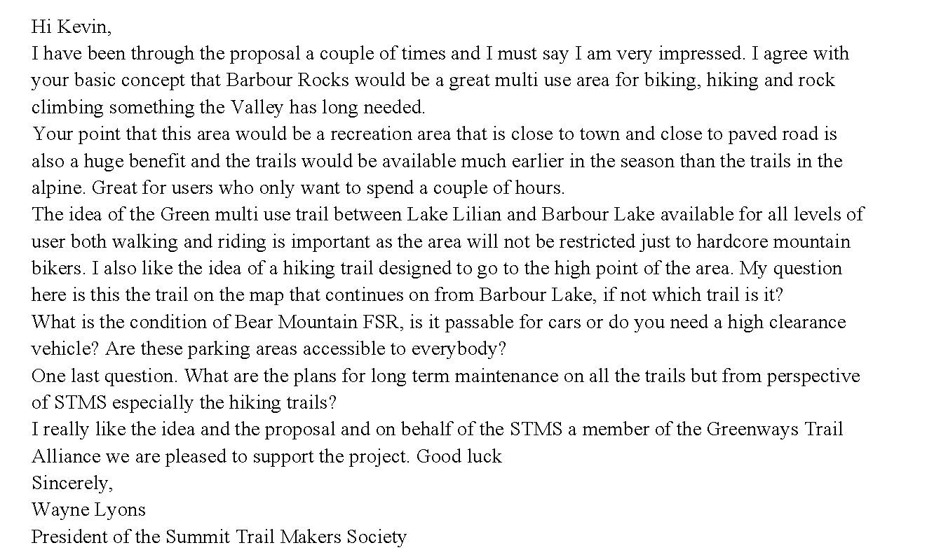

Radium Chamber of Commerce

Columbia Valley Chamber of Commerce

APPENDIX ‘E’: VAST Resource Solutions - Vegetation Assessment and Recommendations for Proposed Barbour Trails – April 2016
For Columbia Valley Cycling Society

APPENDIX ‘F’: “Wildlife Assessment and Recommendations for the Proposed Barbour Rock Recreational Trails”, January 2017 - Prepared by: Eva M. Boehringer, MRM, RPBio

APPENDIX ‘G’: Open House Sign-In Sheets and Comments – January 20 & 21, 2017

APPENDIX ‘H’: Preliminary Field Reconnaissance Report (PFR) - Tipi Mountain Eco-Cultural Services Ltd.

